**Experiment No :** 02

**Experiment name :** Write a program to need a matrix of size m*n and print to transpose .

**Methodology :**

Transpose matrix is converting the rows of a matrix into columns, and then converting the columns into rows, that is, if we want to take a matrix, we will convert its elements from the columns we have into another row. We do that through the transpose matrix

**Flow-Chart :**

For(i=0;i<row;i++){for(j=0;j<col;j++)}

Transpos[j][i]= matrix[i][j]

Declear ->I , j , row , col , matrix[10], transpos[10][10]

Input number of columns and rows

Enter elements of matix :

For(i=0;i<row;i++){

for(j=0;j<col;j++)}

Scanf(“%d”, matrix [i][j];

**Code :**

Print: transpose[i][j]

For(i=0;i<row;i++){

for(j=0;j<col;j++)}

Output : Transpos of the matirx

#include<stdio.h>

int main()

{

int i, j, row, col, matrix[10][10], transpos[10][10] ;

printf("Enter rows and columns of matrix : ");

scanf("%d %d", &row , &col);

printf("Enter elements of the matrix : \n");

for(i=0 ; i<row ; i++){

for(j=0 ;j<col ; j++){

scanf("%d",&matrix[i][j]);

}

}

for(i=0 ; i<row ; i++){

for(j=0; j<col ; j++){

transpos[j][i] = matrix[i][j];

}

printf("Transpose of the matrix\n ");

}

for(i=0 ; i<row ; i++){

for(j=0; j<col ; j++){

printf("%d\t",transpos[i][j]);

}

printf("\n");

}

return 0;

}

**Output:**

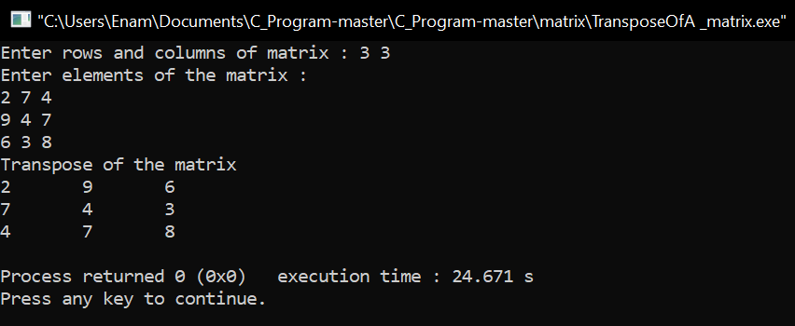

**Result discussion :**

The gist of what I learned from this program is.If we look at the transport matrix, we can see that the elements that we have inputted in the form of rows for the matrix are shown to us in the form of columns in the transport matrix, this is the operation of the transport matrix.